A1 CAMERA CLUB.
1981 – 2021 40th ANNIVERSARY.

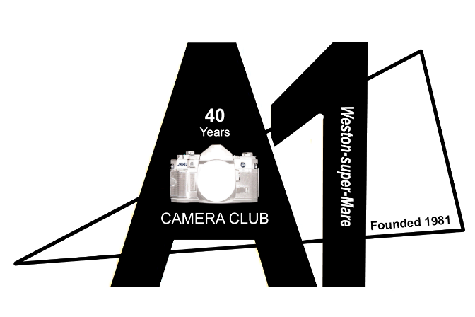

In the late 1970s, a group of mature students completed a course on photography at Weston College. Friendships were formed and rather than go their own ways and lose contact with each other, these photographers decided to meet away from the College. At first, meetings were held every two weeks in local pubs and in 1981 the group decided to create a formal Club.

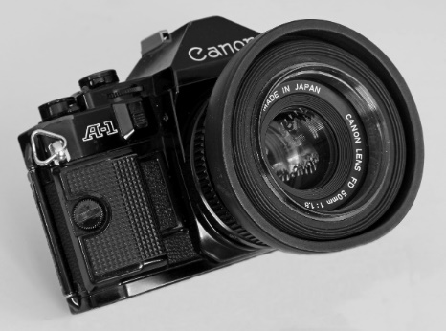
The iconic camera at that time was the Canon A1 35mm SLR camera and the members decided to adopt its name.

A1 Camera Club was born.

The Canon A1 camera shown here was generously presented to the Club by Bernard and Anthea Merrick at our Annual Summer Exhibition held at Weston Museum in 2018.

The first documentary evidence which we have of the Club’s formation is an application to open its first bank account with Lloyds Bank, Weston-super-Mare, signed at a Meeting held on 23 July 1981. It is likely that this is the date of A1 Camera Club’s first Annual General Meeting. Since we do not now have any Club documentation preceding that date that tell us anything about the Club in its very earliest days, 1981 is considered to be the year that the Club was founded and this year, 2021, sees us celebrating our 40th Anniversary. The Club has come a long way since those early days.

After meeting at various locations over the years and now meeting weekly, the Club moved in 2006 to the newly-built St Georges Community Centre, where the Club still meets. Or rather, we would be meeting there if we were permitted to do so! The Coronavirus lockdowns have prevented us from holding meetings at that venue since March 2020 but we have been continuing with our regular Tuesday meetings courtesy of Zoom! These virtual meetings have proved very successful, have been well attended and we have been delighted that several new members have joined the Club during lockdown. This has been extremely pleasing as it shows the strength of the Club when we know that some other camera clubs have been struggling during these unprecedented times.

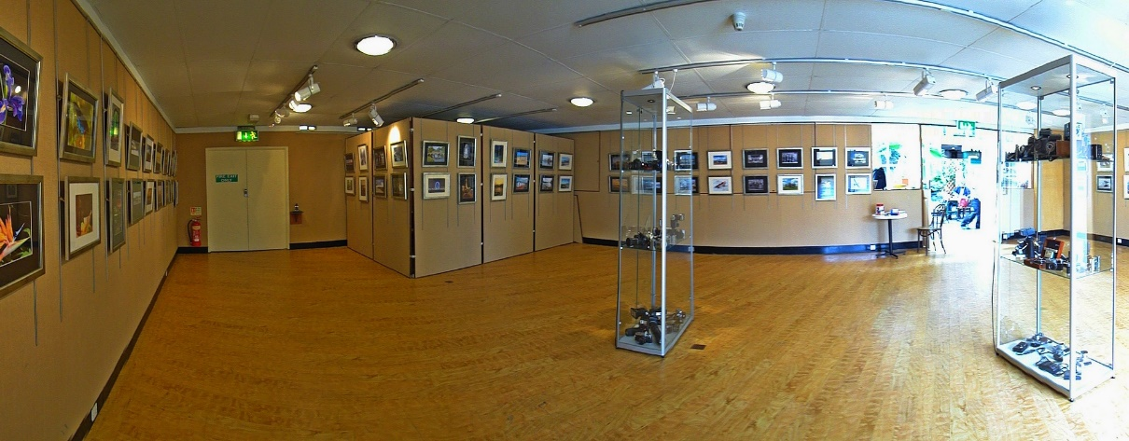
In 2011, the Club held its first Annual Summer Exhibition of members’ framed prints at Weston Museum. This proved to be a great success and further Exhibitions were held in 2012 and 2013.

The Private Preview Evenings of each of these Exhibitions were attended and declared Open by the Guests of Honour, the Town Mayor and Mayoress. During the Preview of the first of these Exhibitions, a conversation between Keith Spicer, Club Chair, and Cllr John Crockford-Hawley, Chair of the Museum Steering Group, resulted in the Club being asked to photograph all the exhibits then on display in the Museum prior to its refurbishment. Our portfolio of images formed part of the successful Submission to the Heritage Lottery Fund for a Grant towards the cost of the refurbishment of the Museum.

When the Museum closed in April 2015 to prepare for the refurbishment project, Club members photographed the decant of all the artefacts by Museum staff and volunteers and Curators from the Somerset Heritage Centre in Taunton. We then photographed the stripping out of all fixtures and fittings, during which time some interesting painted murals were discovered behind panelling. We continued with recording the building and construction work throughout the refurbishment project, the manufacture and fitting of the display showcases and the installation of all the exhibits currently on display. We played an active role in taking photographs to be used in two of the new exhibits, these being the “Weston Then and Now” and “Weston Voices” displays. We were present to photograph the re-opening of the Museum as you see it now, in August 2017.

Many of the thousands of photographs taken throughout the refurbishment project, together with a time-lapse video recording, were used in the major exhibition in the William Mabel Gallery, “The Making of Weston Museum”, to celebrate the successful project.

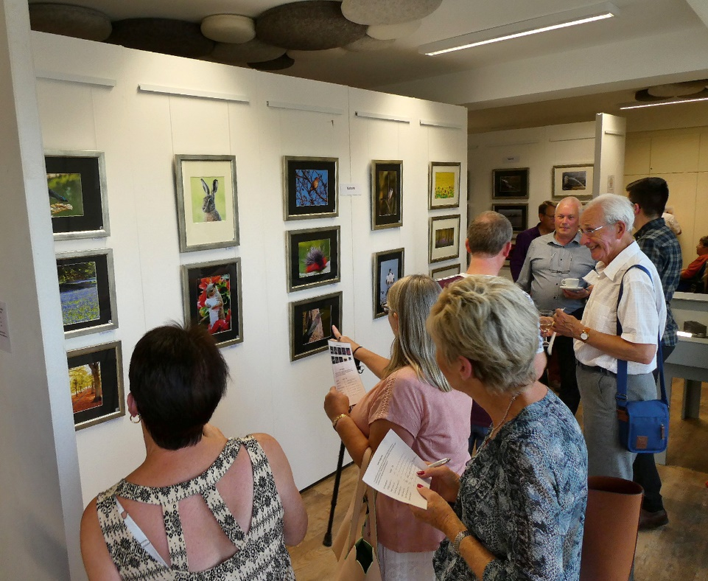
We were then able to resume our highly successful Annual Summer Exhibitions at the Museum in 2018 and 2019, in both cases the Private Previews were attended by the Mayor and Mayoress of Weston.

Sadly, because of the Covid pandemic, we could not hold our Exhibition at the Museum in 2020 and we will again be unable to do so this year. We have, however, held a Summer Exhibition and also a Winter Exhibition on our website, and these have both been very well visited. In both cases, the Town Mayor generously wrote an Introduction. We are now planning an online Summer Exhibition later this year to celebrate our 40th Anniversary .
The Club is proud of its commitment to volunteering in the community and over the years, members have provided photographic support to a number of local organisations and charities, including North Somerset Council Millennium Holiday Guide for Weston super-Mare, the RNLI, the RNIB, St Georges Community Centre Charity, Weston Tourism, the Multicultural Friendship Association and local authors with images for charity book covers.
Members have undertaken photographic projects for the Greek Community of Weston-super-Mare, Alzheimers Society, Uphill Village Society and Citizens Advice Bureau, providing images to be used in Exhibitions by those organisations in the Community Gallery at Weston Museum.
More recently, Club members have been very active in providing photographic support to Weston HospiceCare at charity events including the Mendip Challenge, Women’s Midnight Beach Walk, Men’s March and It’s a HospiceCare Knockout, together with other events and activities.
The Club has been privileged to be invited by Weston-super-Mare Town Council to photograph the Annual Service of Remembrance held in Grove Park, the Annual Civic Service, Weston Air Days and Armed Forces Day and several other events and Receptions. The Royal Marines Band asked to be given some of the images taken of the Band on Parade on Armed Forces Day.
The philosophy of the Club is enshrined in its Constitution, which opens with this statement:-

The objective of the Club shall be to promote photography as an enjoyable hobby and
to encourage and develop the knowledge and interest of Club Members of all ages and
abilities in all aspects of photography.

We plan a programme of weekly activities to run from the beginning of September through to the early part of June each year, to include four quarterly competitions, practical demonstrations and talks presented by members and guest speakers. We always stress to the members that “This is your Club, tell us what you want” and our Programme Secretary will try to incorporate members’ requests into the programme.
In a normal year, these activities would take place in the Clubroom but have had to be held online since March 2020.

During the coronavirus lockdown, we were unable to arrange our usual programme of Summer photoshoots from June to August in 2020 so we continued with the online weekly meetings in order to maintain members’ interest. We expect to be able to resume our Summer programme this year, in groups of up to six members if that is the maximum number permitted by restrictions in force at that time. Again, we ask the members to suggest where they would like to meet and these venues range from Ham Wall and Steart Marshes for wildlife photography, to Severn Beach for the Severn Crossing, the sea and the sunset, to Brean Down for the landscape, the historic Fort and the sunset. Members find these outings very enjoyable and look on them as opportunities to meet and enjoy their photography together in a relaxed atmosphere. Less-experienced members find these activities very rewarding as there will always be more experienced members ready and willing to help with technique and camera settings and to pass on their knowledge and experience.

The majority of our new members first contact us through our excellent website, where you will be able to find our current programme of activities:-
www.a1cameraclubweston.org .
In the near future, you will also find there a much-expanded version of this article, to include contributions from several Club members.
If, after reading this history of A1 Camera Club and learning more about our philosophy and activities, you feel that your journey in photography would be made more enjoyable by becoming a member of the Club, please don’t hesitate to get in touch with us through our website. We would be delighted to welcome you, initially to our weekly Zoom virtual meetings and to our Summer photoshoots and then, when restrictions allow, to our meetings in our Clubroom at St Georges Community Centre.
In line with our commitment to the community, we would also like to hear from you if you are associated with a charitable or voluntary organisation and you feel that Club members might be able to assist you in some way as volunteer photographers.
John Scaife,
Chair, A1 Camera Club.
NJohnScaife@aol.com

