Your camera’s metering modes are built to give you a correct reading under most average situations. But when you’re faced with an exceptional situation, your camera’s metering can easily be fooled, thinking a scene is brighter or darker than it actually is. This is where knowledge of the zone system can save you a lot of trouble, and help you capture not only correct but also intriguing exposures every time.
Although calculations for the zone system were originally based on black and white sheet film, the Zone System is also applicable to roll film, both black and white and color, negative and reversal, and even to digital photography.

Benefits of Utilizing the Zone System
- Capturing a correct exposure every time, even in the trickiest light or scene situations.
- Having a precise evaluation of your scene’s tones and dynamic range prior to even making a shot.
- Knowing when you need to use graduated neutral density filters.
- Knowing exactly how far apart to take exposure bracketed shots for later blending.
- Determining the situations where you need to use a fill flash to get a correct exposure.

Middle Grey
The camera metering is designed to give correct readings under average circumstances. This means that the camera would look at a scene and try to render it as average reflectance (18% reflectance), which is middle grey (a value right in the middle between pure black and pure white). When a scene contains too much bright, however, the camera tries to render it as average so it darkens it causing under-exposure. On the other hand, when a scene contains too much dark, the camera tries to render it as average so it lightens it causing over-exposure.
We as human beings see in color rather than black and white, and there are colors that are considered average. Meaning, they reflect an average amount of light, which is around the same amount that middle grey reflects. Learning the average tones is fundamental for deploying the Zone System.

The Zone System’s Key Concepts
The zone system divides a scene into 10 zones on the tonal scale (though there are variations of 9 and 11 zones). Every tonal range is assigned a zone. Every zone differs from the one before it by 1 stop, and from the one following it by 1 stop. So every zone change equals 1 stop difference. Zones are identified by roman numbers, with the middle tone (with 18% reflectance) being a zone V which is zone 5.
For us digital photographers, we are only concerned with zones III through VII (zones 3 through 7). The darkest part of a scene would fall into zone III, while the brightest part of a scene would fall into zone VII. Anything darker than zone III would render as pure black with no detail (under-exposed), while anything brighter than zone VII would render as pure white with no detail (over-exposed).
If you point your camera at an area with average reflectance and obtain the correct meter readings (a zero on the light meter), that area would be rendered as average. If you open up your lens or slow down your shutter speed by one stop, that area will become over-exposed by one stop. If you close down your lens or increase your shutter speed by one stop, that area will become under-exposed by one stop.
Now, we’ve agreed that an average tone is naturally placed into zone V. If you over-expose it by one stop, you’ll be placing it in zone VI (zone 6), causing it to render brighter than it actually is. If you under-expose it by one stop, you’ll be placing it in zone IV (zone 4) causing it to render darker than it actually is.
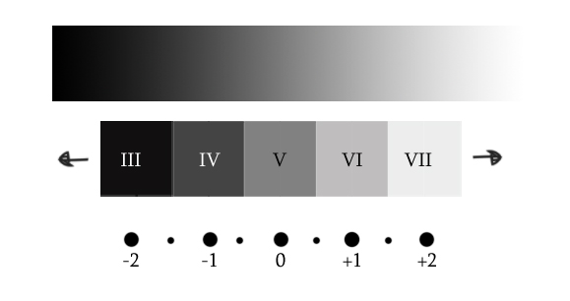

Placing Different Color Tones in Different Zones
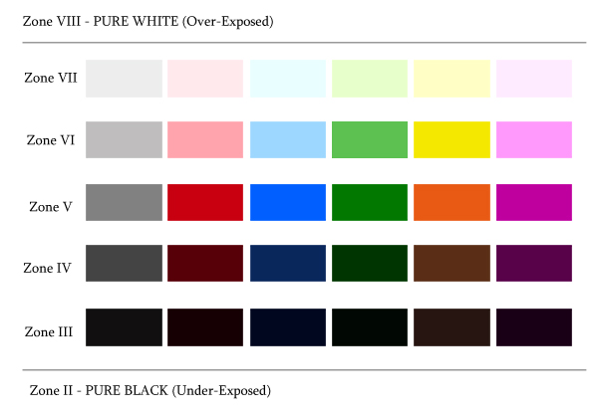
As can be seen by the above image, average colors would render correctly when put in an average zone which is zone V. By render correctly I mean, they will appear on the final photo the same way they look in reality with no over or under-exposure. Those tones include green grass or tree leaves, red flowers, clear blue skies, 18% grey card and the like…
Color tones that are a bit brighter than the average, should be placed into zone VI. Those colors are more like pastels, or faded average colors. Those tones include pure yellow, bright-pinkish red, baby blue, baby pink and the like…
Color tones that are brighter than that should be placed into zone VII. These include white snow, white clouds, fog, smoke, mist, bright sand…
Color tones slightly darker than average should be placed into zone IV. Those include tree trunks, dark blue skies, and so on…
Color tones that are darker than that should generally be placed into zone III. Those tones include black puppies, black shoes, extreme shadows, coal, and the like…
In digital photography, a generally correct exposure (technically speaking) of an average scene is one that is exposed for the mid-tones, with no blown out highlights. I emphasize on blown out highlights because, highlight clipped photo details are more troublesome than shadow clipped photo details.
So if the dynamic range of a scene is greater than one to be captured with only one shot, you have the choice to sacrifice either the highlights or the shadows of a photograph. And unless the jeopardized highlight area is really too small to have any significance, you should always protect the highlights. Blown-out highlights yield a feeling of something missing in the photo, while blown-out shadow detail is more acceptable and sometimes even intentional for specific effects.
So to correctly expose an average scene, spot an average color or tone. Adjust your camera settings till you get the light meter’s hash mark on zero for that color, make sure you’re not over exposing your highlights and take the shot.
Below are a few photos, each with the color tone interpretation right below it. This is to give you an idea on how to evaluate different colors, break down your scene, and place each tone in its corresponding zone.
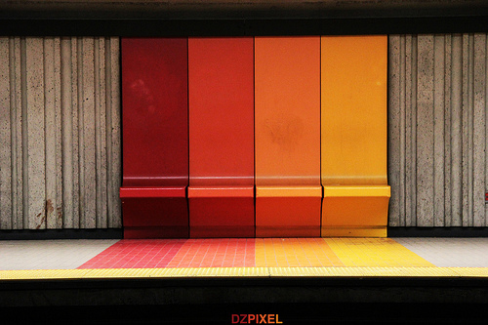
Photo by Samy Lamouti dzpixel
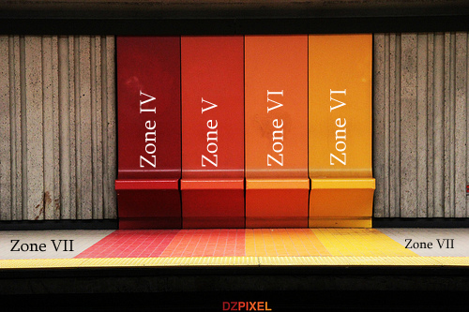
In the above image, the yellow is a zone VI. Yellow is generally always placed in zone VI because it has +1 stop more reflectance than average colors. The slightly bright orange can also be considered a +1 here, maybe even a +1/2.
The saturated orange is average color so its placed in zone V. Red is usually always considered an average color unless it’s too dark or too bright. Here it’s placed in zone IV for being darker than average. The floor is really bright, so it is placed in zone VII.
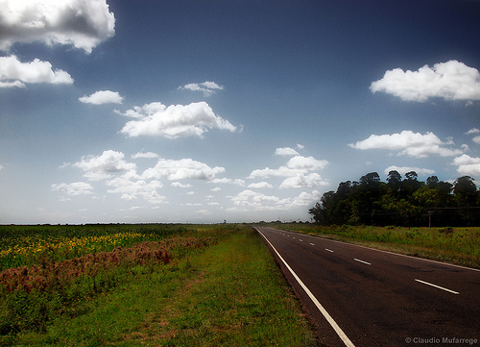
Photo by Claudio Alejandro Mufarrege
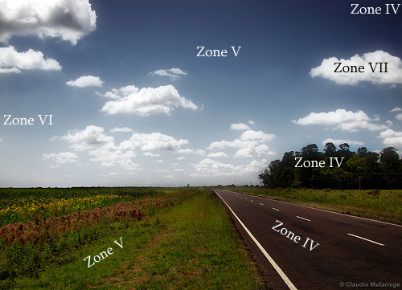
In this photo half way through the sky, the blue is average so it’s placed in zone V. Towards the bottom, it gets brighter, right around zone VI. At the very top, it is around a -1 stop darker than average, so it is placed in zone IV. Regarding the trees and the grass, foliage usually always has an average color unless it’s very dark or very bright.
In this photo, the grass is around average so it is placed in zone V. The trees in the back to the right are approximately a -1 stop darker than average, so they’re being placed in zone IV. The clouds are white but still retaining detail, so they’re a zone VII. As for the road, its around -1 stop darker than average (maybe even a -1 ^{1/2} stop darker) so it’s being placed in zone IV (or in the middle between zone IV and Zone III).
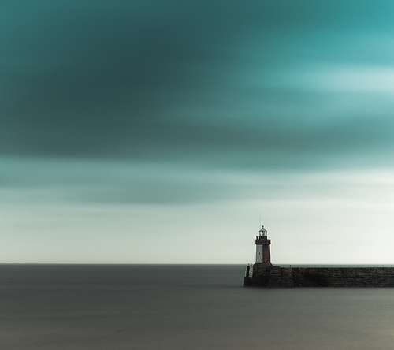
Photo by s k o o v
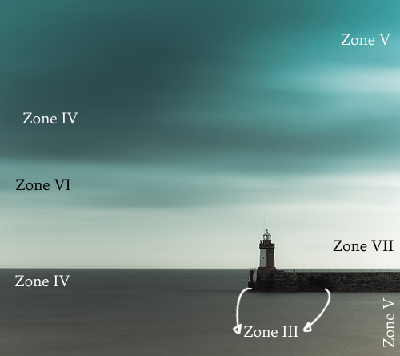
In the photo of the lighthouse above, the sea towards the bottom is around average so it is placed in zone V. Going higher though, it starts getting darker till it gets around a -1 stop at the very top so that area could be considered a zone IV.
As for the sky, it’s around average color at the top and to the right, so that area is considered a zone V. Going down and to the left it gets a -1 stop darker than average, so that area would be a zone IV (maybe slightly brighter than a zone IV, so you could consider it a -1/2 or -2/3).
A little further down it starts to brighten up moving into a good zone VI and eventually a zone VII at the very end to the right. As for the dock, the color is very dark with detail, so it is considered a zone III.
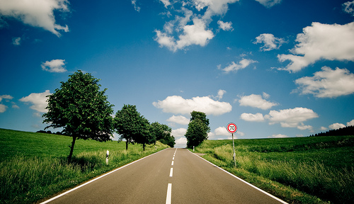
Photo by Ben Fredericson
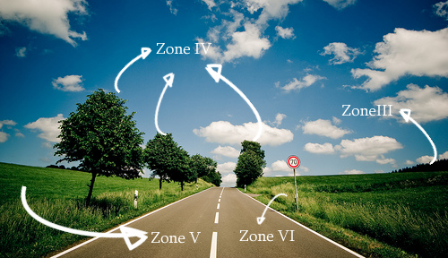
I’ve chosen this photo to show you the varying tones foliage can take and how you would go about placing the different tones of green into different zones. To begin, the grass to the left of the frame is average reflectance, so it is placed in zone V.

