Exercise 1 – Common processing and exposure adjustments
Source file: DSC_9339.TIF (unprocessed TIF file)
All source files here:
Objective: Use Photoshop to process common edits and achieve a more balanced exposure.
Unadjusted Adjusted
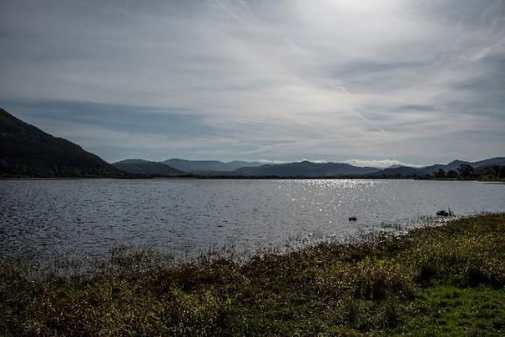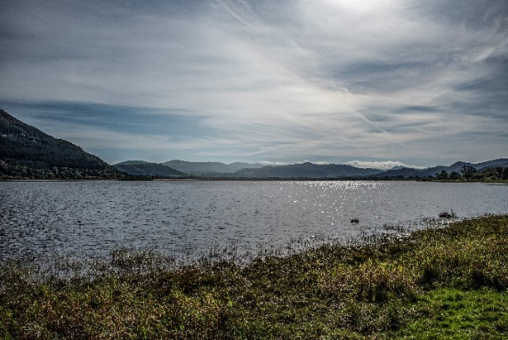
Approach and techniques to try:
- Open file DSC_9339.TIF. it will show as a locked layer in the layers panel
- Camera Raw adjustments will launch automatically when you open Raw files but not with TIF files but you can process a Camera Raw adjustment on a duplicated TIF layer after import.
- Duplicate the layer (to keep original layer unadjusted). Ensure duplicated layer is “unlocked”.
- Camera raw adjustments are made in Photoshop by selecting Shft+Ctrl+A or from “Filter” on the Application Bar. Note adjust the exposure etc. to get the foreground on the left of the image the way you want it. At this stage do not worry about the other areas of the image.
- Add a gradient overlay or gradient layer from right to left on the image to balance exposure.
  - Gradient Overlay is accessed using the fx icon at the foot of the layers panel.
  - Gradient Layer created by adding a mask to the layer and then painting the mask with a white to black gradient using the gradient tool from the Tools Panel.
- Adjust the exposure and detail in the sky by:
  - Using the quick selection tool to select the sky.
  - Creating a layer mask using the Layer/Layer mask/Reveal selection option from the Application Bar.
  - Apply a camera raw filter to this layer to fine tune the exposure and detail in the sky.
- If the hill on the left of the image is still a bit too dark make a further adjustment to lift the exposure by:
  - Using the quick selection tool to select the hill.
  - This selection may be a bit tricky so practice refining your selection to get it right. Try adjusting the selection with the selection tool using the add and subtract options in the options bar control panel, or by right clicking in the selected area on the image and choosing select and mask from the drop down menu.
  - If you are confident with your selection you can create a new layer with just the hill using the standard copy and paste commands. If you are not 100% happy create a new mask layer by duplicating the current layer and then adding a mask as above.
  - Apply an exposure adjustment using the adjustments icon at the bottom of the Layers Panel.
- Save your work either as a PSD file if you want to return to it and make further adjustments or by “flattening” (Layer/Flatten image from the Application Bar) and then saving in your preferred format.

Exercise 2: Example of using layers to replace a problem area in an image
Source file: DSC_8008.TIF (already adjusted for dynamic range etc.)
All source files here:
Objective: Use photoshop layers and the transform tools to replace a problem area in an image.
Unadjusted Adjusted
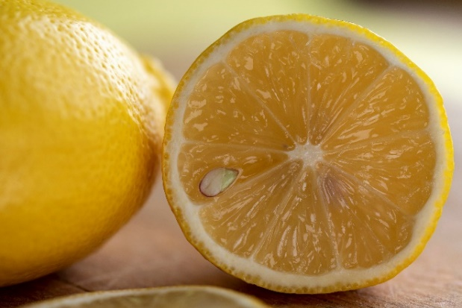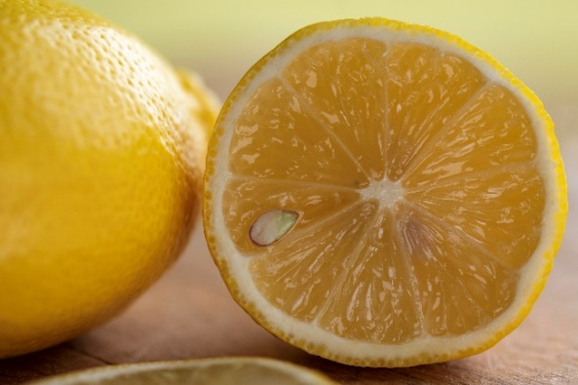
Approach and techniques to try:
- Open file DSC_8008.TIF
- Duplicate the background layer (to keep original layer unadjusted). Ensure the new layer is unlocked.
- Try cloning to remove the dark area (use a new layer for the cloning and the clone tool options set to “Current & Below” in the sample box). You will find it is very difficult to get a natural looking result. Delete or hide your cloning layer and then try this approach.
- Select the first layer that you duplicated. Now create a second duplicate layer.
- Using the “quick selection” tool from the Tools Panel select the area above the lemon in the top right corner of the second duplicate layer. Then create a mask layer hiding the selection.
- Use the “\” key to reveal the layer mask or the “Select and Mask” option from the Application Bar (Select/Select and Mask).
- Use the brush tools from the Tools Panel or the brush tools in “Select and Mask” to refine the mask so that it covers the area you want to fix. Try working with both methods and explore the “Select and Mask” brush tools to see what works best for you.
Note: When using the brush tool a black brush adds to the masked area, a white brush removes the mask and the “X” key toggles between black and white brushes. When using “Select and Mask” the “-“ tool option adds to the masked area and the “+” tool option removes the mask.
- Select the first duplicated layer and then select the move tool from the Tools Panel. Place the cursor in the area that has been masked out and drag the first layer to the right (the move tool will select the second layer if you click outside the masked area). Try to get a good background match showing through from the first duplicated layer. You will find that the green background areas in the first layer are not large enough to fill the space on the right and that the background colour fades in the wrong direction to achieve a good match.
- Select the first duplicated area and then select “Flip Horizontal” (Edit/Transform/Flip Horizontal from the Application Bar). This will flip the layer left to right.
- Select “Free Transform” (Edit/Free Transform from the Application Bar). You will see a blue bounding box with “reference points” on the corners and sides. Click and drag the reference points to resize the first duplicate layer and click in the centre to move the image until you have the best background fill. Use the clone tool at lower opacity to blend the edges and get an invisible transition where the new background meets the old.

Exercise 3: Example of combining images to make a composite of two or more images
Sources files: DSC_8642.TIF, DSC_ 8644.TIF and DSC_8648 (portion).TIF
All source files here:
Before
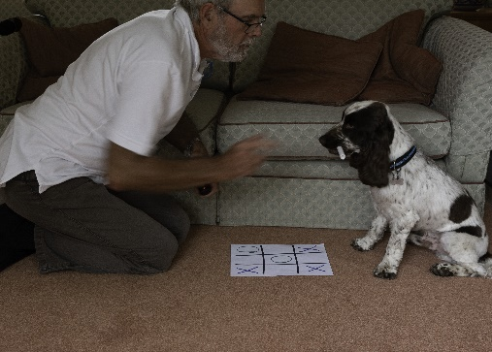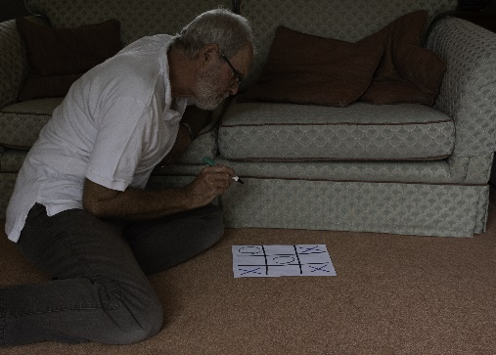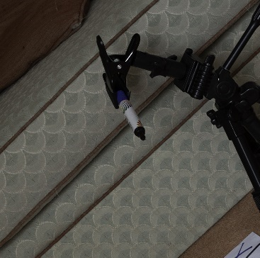
After
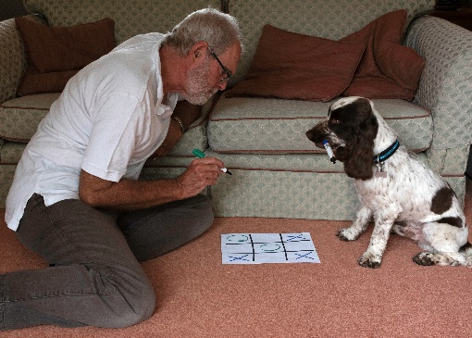
Objective: Use photoshop layers and the transform tools to combine images.
Approach and techniques to try:
- Open the DSC-8642.TIF and DSC_8644.TIF files in photoshop and copy them as layers into one document with DSC_8642.TIF on top of DSC_8644.TIF.
- Save this file immediately as a PSD document so that there is no risk of overwriting the original files.
- The first step is to align these two layers. Select both layers in the Layers panel and then select “Auto-Align Layers” (Edit/ Auto-Align Layers from the drop-down menu). Note when this approach does not work one of the most effective ways to manually align layers is to set the top layer blending mode to “Difference” areas that match are then shown in black and areas that don’t appear in light colours which makes it easier to see when you have moved a layer to pixel perfect alignment.
- You now need to isolate the dog in the top layer. As the background is the same in each image you can mask the layer using a rough selection around the dog and any shadow areas using one of the selection tools as done in previous exercises.
- There will be exposure differences between the two layers. Use the “Camera Raw Shft+Ctrl+A ” filter (Filter/Camera Raw Shft+Ctrl+A from the Application Bar) to adjust the exposure and if necessary the tones, contrast etc in the first layer.
- Select the top layer and apply the same filter using the “Camera Raw Shft+Ctrl+F” filter (Filter/Camera Raw Shft+Ctrl+F form the Application Bar).
- There will still be some exposure differences. Try opening the “Camera Raw Shft+Ctrl+A” filter and entering a small exposure adjustment followed by repeated use of the “Camera Raw Shft+Ctrl+F” filter until the exposure in the two layers is matched. As an alternative you can also try adding an exposure adjustment layer to the top layer and adjusting the exposure using the slider.
- When you are happy that you have achieved a good match between the two layers use the brush tool set at low opacity on the top layer mask to blend the unmasked area with the first layer.
- The dog is holding a dummy felt marker pen, we need to bring in the real thing so select “Place Embedded” (File/Place Embedded from the Application Bar) and select the file DSC_8648 (portion).TIF. This will bring the image into the current file as a “smart object” on a new layer.
- Smart objects can be resized and rotated without losing pixels and therefore quality. Either use the difference blending mode or reduce the opacity of the smart object layer so that you can see the underlying layer and can use the move and size tools to position the real felt marker pen over the dummy one held by the dog. When you are happy that you have positioned the marker pen correctly click on the tick on the Application Bar or press the return key to accept the move.
- Now you need to use the masking techniques practiced already to mask out this layer so that only the marker pen is showing.
- To finish the image add a catchlight to the dog’s eye to bring it to life a bit more and then save as appropriate.

Exercise 4 – Another smart use of blending modes
Source files: DSC_3578.TIF and DSC_3669.TIF
All source files here:
Source images Blended
Objective: Use photoshop layers and the blending modes to combine images.
Approach and techniques to try:
- Open the DSC_3578.TIF and DSC_3669.TIF files in photoshop and, starting with DSC_3578 copy them as layers into one document.
- Save this file immediately as a PSD document so that there is no risk of overwriting the original files.
- There are a number of ways these images can be combined. A quick and very effective way to combine them is to use layer blending modes.
- The first step is to select a soft edged black brush.
- Now use the brush to paint out the coin and faint light trail below the coin in DSC_3578. Keeping your brush strokes fairly close to the coin and light trial should give the most natural looking blend.
- Next use the brush to paint out the hand, the hand movement blur and the distracting light line in the lower left of DSC_3669. Again keeping your brush strokes fairly close to the subject should give the most natural looking blend.
- Now select the top layer and then select the “Lighten” blending mode.
- All done, you can save your image and go get a coffee. However, if you want to try some other things try experimenting with different blending modes and try achieving the same result using masks and using cloning techniques. Compare the images close up, which gives the better result and which is the most efficient?

Further reading and useful tutorials
There is a free ebook covering layer blend modes published by Colin Smith of Photoshop Café.
PDF can be downloaded from here:
Photoshop Café has also produced some very good YouTube tutorials, links below:
How to use PHOTOSHOP LAYER MASKS + 7 TRICKS with masks - YouTube
how to combine and blend photos in Photoshop - YouTube
How to perfectly match colors in Photoshop when combining photos. - YouTube
5 most useful LAYER BLENDING modes in Photoshop - YouTube

